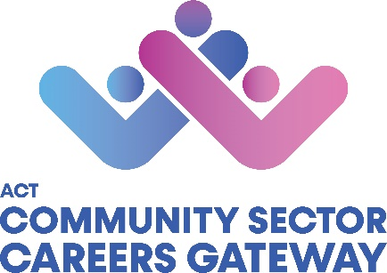

ACT COMMUNITY SECTOR CAREERS GATEWAY
CAREER AMBASSADOR INFORMATION
Thank you for showing interest in becoming a Career Ambassador. Your career journey and insight into the sector is valuable to us and the people attending our events.
We note that the role of career ambassador is a volunteer role, and no remuneration is provided. We thank you for your understanding.
Please fill out the questions below. It helps us understand your availability as well as which events will be the best match. This information is private and will not be shared with others outside the ACTCSCG project staff.
Full Name: |  |  |  |  |  |  | Pronouns:
Business Hours Availability:
Organisation: |  |  |  |  |  |  |  |  | Position:
Email: |  |  |  |  |  |  |  |  | Phone Number:
Do you identify as Aboriginal and/or Torres Strait Islander?
☐ Yes, Aboriginal |  | ☐ Yes, Torres Strait Islander |  | ☐ Both |  |  |  |  |  |  | ☐ Prefer not to say |  |  | ☐ Neither
Tell us about your career journey:
Which of the following areas are relevant to you and/or your career?
☐ Aboriginal and Torres Strait Islander affairs |  |  |  |  |  |  | ☐ Energy and Climate Change
☐ Advocacy |  |  |  |  |  |  | ☐ Family Services
☐ Aged Care |  |  |  |  |  |  | ☐ Health
☐ Alcohol and Other Drugs |  |  |  |  |  |  | ☐ Housing and Homelessness
☐ Children and Young People |  |  |  |  |  |  | ☐ Legal and Human Rights
☐ Community Development |  |  |  |  |  |  | ☐ LGBTIQA+
☐ Culturally and Linguistically Diverse |  |  |  |  |  |  | ☐ Mental Health
☐ Disability |  |  |  |  |  |  | ☐ Monitoring and Evaluation
☐ Domestic and Family Violence |  |  |  |  |  |  | ☐ Volunteering
☐ Early Childhood |  |  |  |  |  |  | ☐ Other:
☐ Education and Training
Due to the nature of this project, Working with Vulnerable People (WWVP) Card is a requirement as an ambassador. If you don’t currently have a WWVP card, we ask that you complete an application here. Applications are free for volunteers.
Please provide the registration number and expiry date of your WWVP Card:
Registration No: |  |  |  |  |  | Expiry Date:
On occasions, Careers Ambassadors may be invited to speak about their career journey at careers expos, classroom sessions, events etc being a mixture of face to face and online.
Do you have capacity to undertake with reasonable notice i.e. two weeks in advance?
☐ Yes |  |  |  |  |  |  |  |  |  | ☐ No
Some events may take place out of business hours and or on weekends.
Please confirm your availability?
☐ | Business hours only | ☐ | After hours only | ☐ | Available during business hours and after hours |  |  |  |  |  | ☐ | Available after hours and weekend | ☐ |  | Not available after hours or on weekends
Do you have any access requirements you would like us to be aware of?
If so, please advise:
Do you give permission for footage taken during events to be displayed on the website, social media platforms and any other promotional material?
☐ Yes |  |  |  |  |  |  |  | ☐ No
Have you had any media training or exposure to the media in the past?
If yes, please provide a brief description of your experience with the media.
Is there any other information relating to your Career Ambassador role we need to know?

Once the form has been completed, please submit to actcscg@actcoss.org.au
If you have any questions or require any clarifications, please don’t hesitate to call us on 02 6202 7200.

